**第六次实验**

Task1

1. A

进行创建

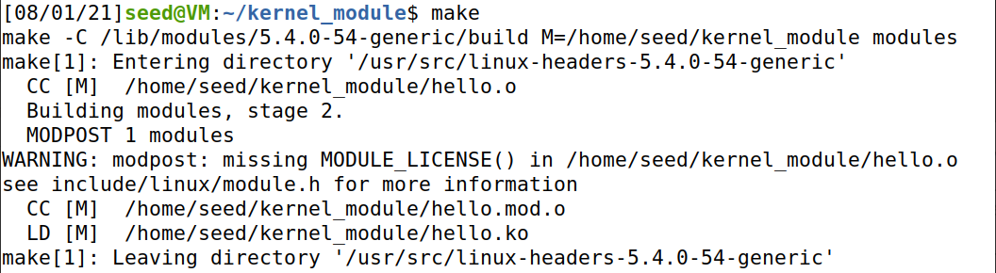

模块信息

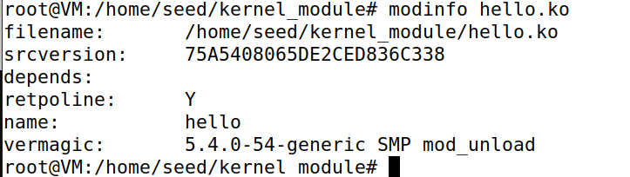

删除后输出Bye-bye World!



1. B

1

未开启防御前，正常连接

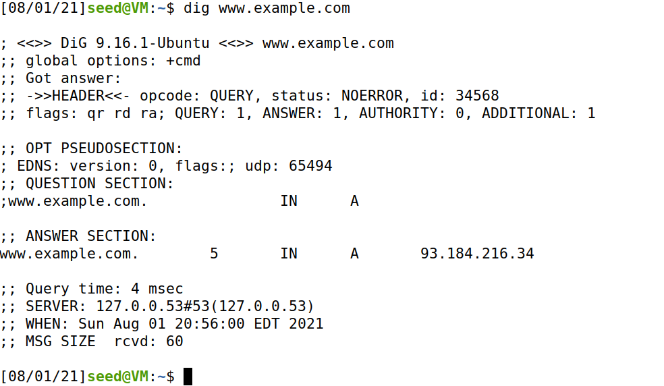

开启防火墙后，连接失败，无法连接到DNS服务器

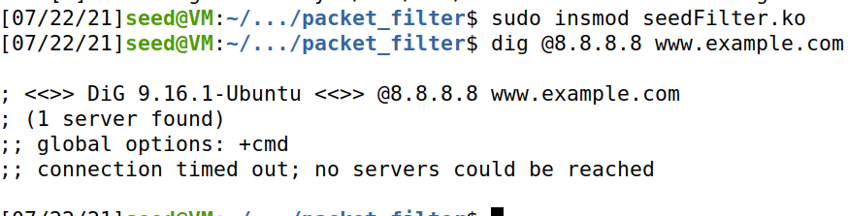

2

将函数挂到五个钩子上

#include <linux/kernel.h>

#include <linux/module.h>

#include <linux/netfilter.h>

#include <linux/netfilter_ipv4.h>

#include <linux/ip.h>

#include <linux/tcp.h>

#include <linux/udp.h>

#include <linux/if_ether.h>

#include <linux/inet.h>

static struct nf_hook_ops hook1, hook2,hook3, hook4, hook5;

unsigned int blockUDP(void *priv, struct sk_buff *skb,

const struct nf_hook_state *state)

{

struct iphdr *iph;

struct udphdr *udph;

u16 port = 53;

char ip[16] = "8.8.8.8";

u32 ip_addr;

if (!skb) return NF_ACCEPT;

iph = ip_hdr(skb);

// Convert the IPv4 address from dotted decimal to 32-bit binary

in4_pton(ip, -1, (u8 *)&ip_addr, '\0', NULL);

if (iph->protocol == IPPROTO_UDP) {

udph = udp_hdr(skb);

if (iph->daddr == ip_addr && ntohs(udph->dest) == port){

printk(KERN_WARNING "*** Dropping %pI4 (UDP), port %d\n", &(iph->daddr), port);

return NF_DROP;

}

}

return NF_ACCEPT;

}

unsigned int printInfo(void *priv, struct sk_buff *skb,

const struct nf_hook_state *state)

{

struct iphdr *iph;

char *hook;

char *protocol;

switch (state->hook){

case NF_INET_LOCAL_IN: hook = "LOCAL_IN"; break;

case NF_INET_LOCAL_OUT: hook = "LOCAL_OUT"; break;

case NF_INET_PRE_ROUTING: hook = "PRE_ROUTING"; break;

case NF_INET_POST_ROUTING: hook = "POST_ROUTING"; break;

case NF_INET_FORWARD: hook = "FORWARD"; break;

default: hook = "IMPOSSIBLE"; break;

}

printk(KERN_INFO "*** %s\n", hook); // Print out the hook info

iph = ip_hdr(skb);

switch (iph->protocol){

case IPPROTO_UDP: protocol = "UDP"; break;

case IPPROTO_TCP: protocol = "TCP"; break;

case IPPROTO_ICMP: protocol = "ICMP"; break;

default: protocol = "OTHER"; break;

}

// Print out the IP addresses and protocol

printk(KERN_INFO " %pI4 --> %pI4 (%s)\n",

&(iph->saddr), &(iph->daddr), protocol);

return NF_ACCEPT;

}

int registerFilter(void) {

printk(KERN_INFO "Registering filters.\n");

// Hook 1

hook1.hook = printInfo;

hook1.hooknum = NF_INET_LOCAL_IN;

hook1.pf = PF_INET;

hook1.priority = NF_IP_PRI_FIRST;

nf_register_net_hook(&init_net, &hook1);

// Hook 2

hook2.hook = printInfo;

hook2.hooknum = NF_INET_PRE_ROUTING;

hook2.pf = PF_INET;

hook2.priority = NF_IP_PRI_FIRST;

nf_register_net_hook(&init_net, &hook2);

// Hook 3

hook3.hook = printInfo;

hook3.hooknum = NF_INET_FORWARD;

hook3.pf = PF_INET;

hook3.priority = NF_IP_PRI_FIRST;

nf_register_net_hook(&init_net, &hook3);

// Hook 4

hook4.hook = printInfo;

hook4.hooknum = NF_INET_LOCAL_OUT;

hook4.pf = PF_INET;

hook4.priority = NF_IP_PRI_FIRST;

nf_register_net_hook(&init_net, &hook4);

// Hook 5

hook5.hook = printInfo;

hook5.hooknum = NF_INET_POST_ROUTING;

hook5.pf = PF_INET;

hook5.priority = NF_IP_PRI_FIRST;

nf_register_net_hook(&init_net, &hook5);

return 0;

}

void removeFilter(void) {

printk(KERN_INFO "The filters are being removed.\n");

nf_unregister_net_hook(&init_net, &hook1);

nf_unregister_net_hook(&init_net, &hook2);

nf_unregister_net_hook(&init_net, &hook3);

nf_unregister_net_hook(&init_net, &hook4);

nf_unregister_net_hook(&init_net, &hook5);

}

module_init(registerFilter);

module_exit(removeFilter);

MODULE_LICENSE("GPL");

Ping10.9.0.1后查询信息，得到函数的输出

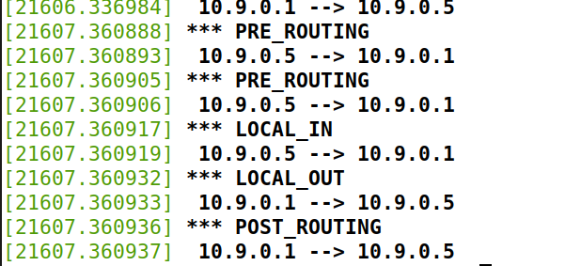

3

#include <linux/kernel.h>

#include <linux/module.h>

#include <linux/netfilter.h>

#include <linux/netfilter_ipv4.h>

#include <linux/ip.h>

#include <linux/tcp.h>

static struct nf_hook_ops telnetFilterHook;

unsigned int telnetFilter(void *priv, struct sk_buff * skb, const struct nf_hook_state *state){

struct iphdr *iph;

struct tcphdr *tcph;

iph = ip_hdr(skb);

tcph = (void *)iph+iph->ihl*4;

if((iph->protocol == IPPROTO_TCP && (tcph->dest == htons(23)

|| tcph->dest== htons(22)

|| tcph->dest== htons(21)))

|| (iph->protocol == IPPROTO_ICMP &&((((unsigned char *)&iph->daddr)[0]==10 &&

((unsigned char *)&iph->daddr)[1]==9

&& ((unsigned char *)&iph->daddr)[2]==0 && ((unsigned char *)&iph->daddr)[3]==1)

|| (((unsigned char *)&iph->daddr)[0]==10 && ((unsigned char *)&iph->daddr)[1]==9

&& ((unsigned char *)&iph->daddr)[2]==0 && ((unsigned char *)&iph->daddr)[3]==1)))){

printk(KERN_INFO "Dropping telent packdt to %d.%d.%d.%d\n",

((unsigned char *)&iph->daddr)[0],

((unsigned char *)&iph->daddr)[1],

((unsigned char *)&iph->daddr)[2],

((unsigned char *)&iph->daddr)[3]);

return NF_DROP;

}else{

return NF_ACCEPT;

}

}

void removeFilter(void){

printk(KERN_INFO "Telnet filter has been removed.\n");

nf_unregister_net_hook(&init_net,&telnetFilterHook);

}

int setUpFilter(void){

telnetFilterHook.hook = telnetFilter;

telnetFilterHook.hooknum = NF_INET_PRE_ROUTING;

telnetFilterHook.pf = PF_INET;

telnetFilterHook.priority = NF_IP_PRI_FILTER;

if(nf_register_net_hook(&init_net,&telnetFilterHook)!=0){

printk(KERN_WARNING "register Telnet filter hook error!\n");

goto err;

}

printk(KERN_INFO "Registering a Telnet filter");

return 0;

err:

removeFilter();

return -1;

}

module_init(setUpFilter);

module_exit(removeFilter);

MODULE_LICENSE("GPL");

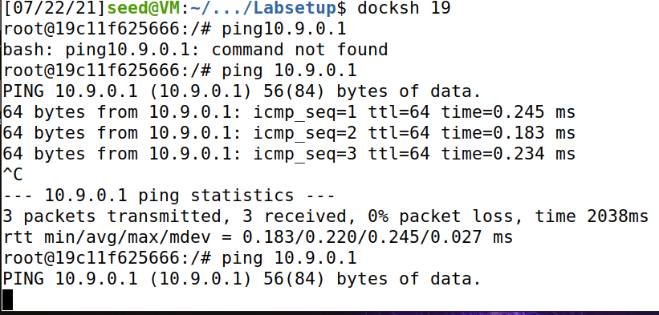

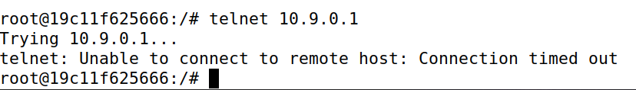

在10.9.0.5上ping和telnet10.9.0.1都不通，防火墙过滤成功

Task2

2.A

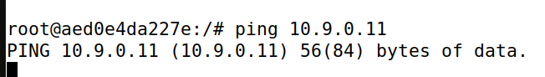

ping不通

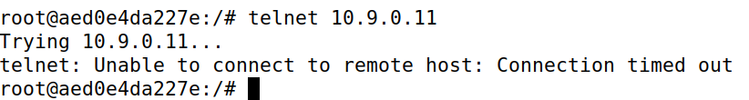

telnet不通

2.B

路由器中设置规则

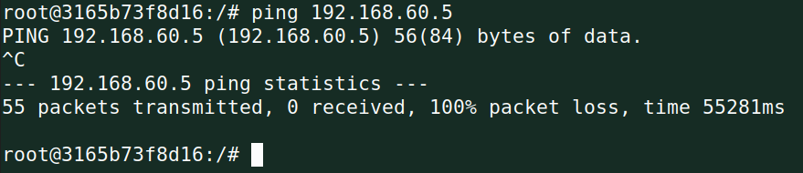

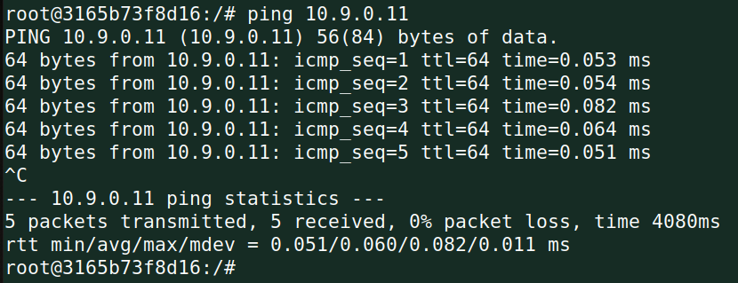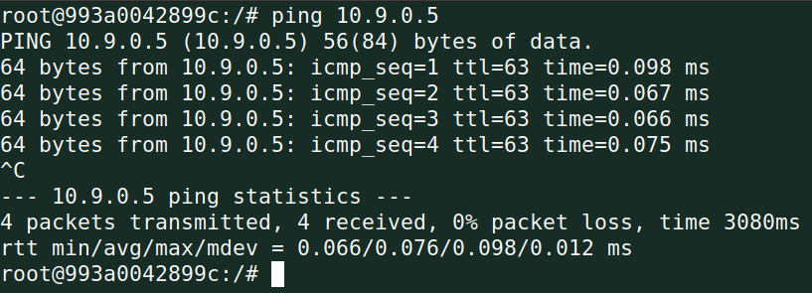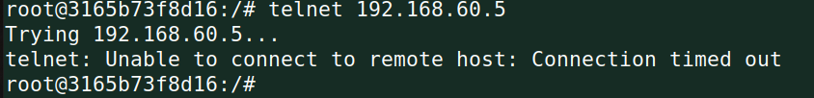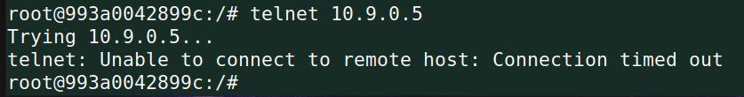

2.C

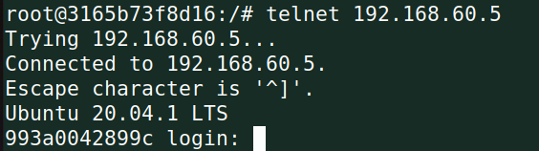

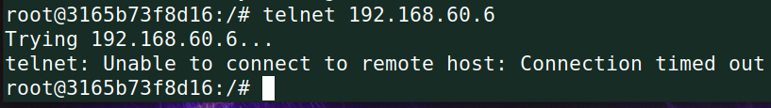

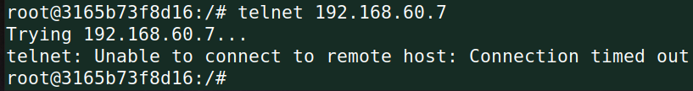

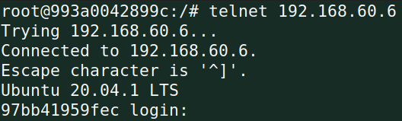

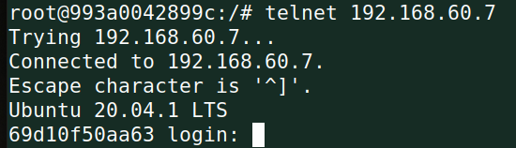

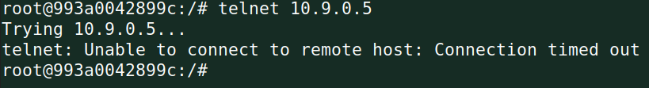

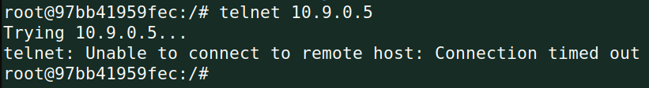

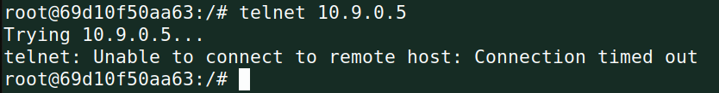

Task 3

3.A

ICMP

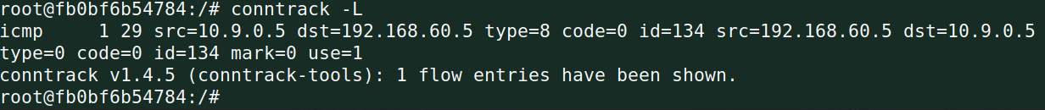

UDP

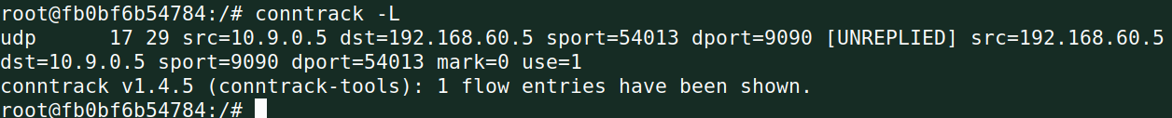

TCP

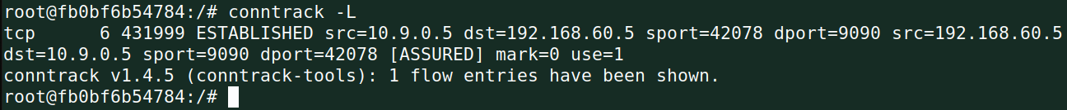

3.B:

使用跟踪连接修改规则如下：

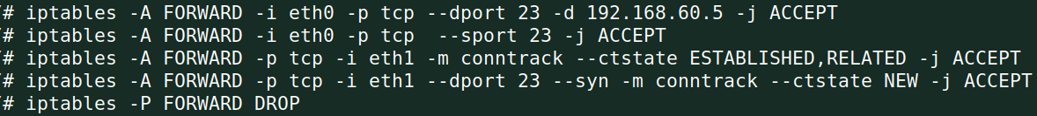

Task 4

运行命令，在主机10.9.0.5里ping主机192.168.60.5，在连续接收到了多个回复后，过一段时间才能接收到下一个回复报文

